Keynote Abstract

The Machine in the Garden and Literary and Cultural Studies

Dr. Fakrul Alam
Professor, Department of English, University of Dhaka

This presentation will try to apply, extend and complicate some of the insights and observations articulated by Leo Marx in his seminal 1964 work, The Machine in the Garden: Technology and the Pastoral Ideal in America in the light of subsequent studies as well as recent developments in technology as well as theory. Marx’s book tried to assess the impact of the advent of technology on the American landscape through selective readings of the works of writers of what has been called the American Renaissance, that is to say, the mid-nineteenth century. But his fascinating study needs to be expanded to other literatures and centuries—what, for example, was the impact of the machine on the mindscape of the English writers of the period? Or for that matter, how did it affect Bengali writers in the modern era? Or if we can march ahead in time, how was the impact of technology seen by artists/writers, first in the age of mechanical, and then in the era of digital reproduction? How did films depict the machine in the garden? This presentation will also attempt to show that the machine in the garden was not only symptomatic of the alienation and environmental degradation inevitable with industrial development, as has been perceived by many sensitive artists/writers, but has also been hailed as fascinating and full of possibilities for their works by not a few of them. Marx himself in, “The Railroad-in-the Landscape: An Iconological Reading of a Theme in American Art”, a piece written in 1988, re-visioned his earlier view, noting “the deep moral ambiguity of material progress”, and this presentation will take stock of this more complicated perspective on the impact of the machine in the garden. It will thus consider the awe at the sight of the machine depicted by not a few writers/artists, a response fully captured in David E. Nye’s 1994 book, American Technological Sublime. Ultimately, my presentation would like to end with the impression that the advent of technology permanently impacted creatively as well as profoundly not only on the physical landscape but also on the imaginative landscape of writers, artists and intellectuals.

Keynote Speaker

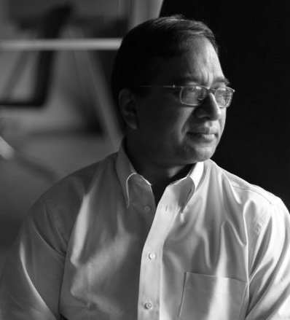
FAKRUL ALAM is an academic, a literary critic, essayist and editor as well as a translator from Bengali. He is Professor of English at the University of Dhaka. He has been a Fulbright Scholar and a Visiting Assistant Professor at Clemson University, USA, and has also been Visiting Professor at India’s Jadavpur University and at Visva-Bharati. He was a member of the jury of the Commonwealth Writer’s Prize for 2003 (Eurasia region) and was an adjudicator for the DSC South Asian Prize for Literature in 2011. He received the SAARC Literature Award 2012 given at the SAARC Literature Festival of 2012 held at Lucknow India on 18 March 2012. He was awarded the Bangla Academy Puroshkar (Literature Award) in the Translation category for 2013 on February 24, 2013. Among his forthcoming works are Gitanjali: New Translations of the Nobel-Prize Winning Poems (Dhaka: UPL) and An Ocean of Sorrow, a translation of the nineteenth century Bengali epic narrative, Bishad Sindhu by Mir Mosharraf Hussain and English, the Language of Power and the Power of Language and other Essays, a collection of essays, some published before, and others newly written for the volume. His publications include Imperial Entanglements and Literature in English (Writer’s Ink: Dhaka, 2007); South Asian Writers in English (Detroit: Thomson Gale, 2006); Jibanananda Das: Selected Poems (Dhaka: University Press Limited, 1999); Bharati Mukherjee ( Boston: Twayne’s Contemporary United States Authors, 1996); and Daniel Defoe: Colonial Propagandist (University of Dhaka Publications, 1989). Among his more recent works is The Essential Tagore (Boston: .Harvard UP and Viswa Bharati: Kolkata, 2011; co-authored with Radha Chakravarty). His translation of Sheikh Mujibur Rahman’s Unfinished Memoirs was published in 2012 by University Press in Bangladesh, Penguin Books in India, and Oxford University Press in Pakistan, and his Rabindranath Tagore and National Identity Formation in Bangladesh: Essays and Reviews (Dhaka: Bangla Academy) in 2013.

